
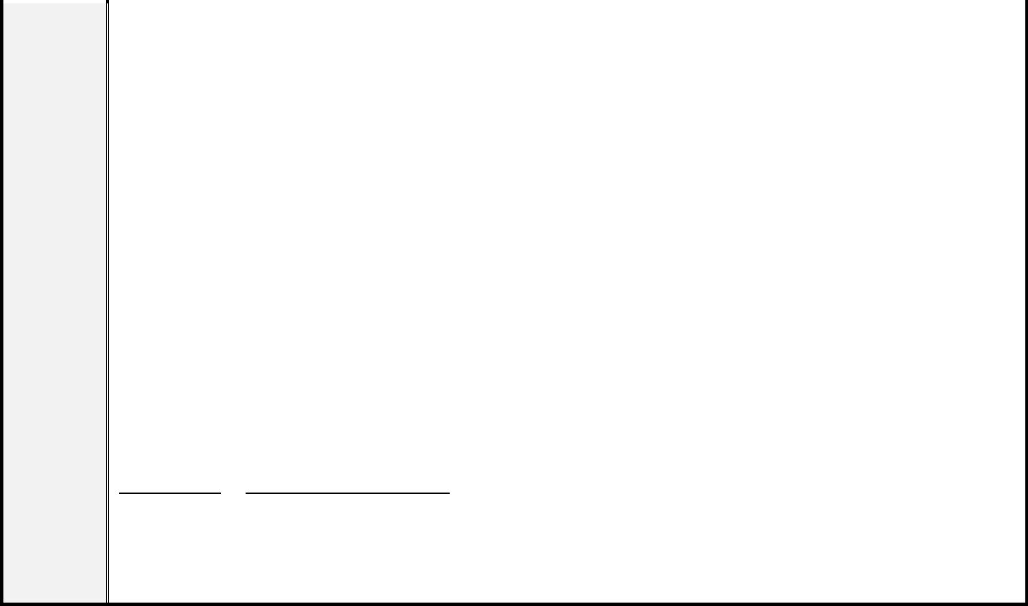
中國文化大學
Chinese Culture University
博碩士班學位論文考試申請表
Thesis Examination Application Form
學年度
Academic Year
學年度(Academic Year)，第
學期(Semester)
研究所組
Graduate Program
□博士班 Doctorate □碩士班 Master
姓名
Name
學號
ID
【申請條件 Application Requirements】
需符合以下事項方得申請學位論文考試
Need to fulfill the following requirements to apply for the degree thesis examination:
修滿各系所規定必修科目及最低畢業學分數
Complete the required courses of the Graduate Program as well as the minimum number of credits
required for graduation.
1.
2.
通過英文文能力檢定標準
Pass the English aptitude evaluation standard.
博士班：在校研修期間發表於學術性刊物與該系(所)學術領域相關之學術性文章一
篇以上。
Doctorate Program: Publish at least one paper in an academic journal which is related to the
professional field of the department while studying at the university.
碩士班：100 學年度起入學之研究生在學期間刊登於學術刊物之學術文章一篇(包
含研討會發表之文章)，並以獲得接受函為準。〔刊物需符合所屬系所規定與認可，
並請繳交相關佐證資料至系所辦公室〕
Master Program: Starting from the 2011 academic year, graduate students must publish at least one
paper in an academic journal, with proof of acceptance.
3.
4.
登錄期刊學術論文 Register an academic publication：學生專區 Student website 申請/
報名作業學位論文考試申請登錄期刊學術論文中填寫資料 Fill in academic
publication information.
符合所屬系所之相關規定
Meet other regulations and guidelines of the individual Graduate Program.
【博士班研究生應繳交資料 Doctorate students should submit the following relevant items】
1.博士學位候選人資格審核申請表 PhD Candidate Qualification Review Form
2.論文考試申請表 Thesis Examination Application Form
3.論文 Thesis
4.指導教授推薦書 Advisor Recommendation Form
5.初審委員審核通過之論文修正說明暨審核表 Thesis revision explanation from the Initial Review
Committee together with the review form
6.英文語文能力檢定通過證明 English aptitude evaluation certificate
7.已刊登之學術文章審核表，並附已出刊之期刊 Approval Form of published academic journal article
with a copy of the published academic journal
指導教授意見 Advisor Comments:
指導教授
：
Advisor
(簽章 Signature or Stamp)
所長
：
Program Director
(簽章 Signature or Stamp)
※本表單僅於校內行政業務使用，並於業務存續期間保留。

